Q1

CHECK (arrDate < depDate)

Q2

<https://ideone.com/A6Nt6E>

CREATE TABLE CourseDetail

( SID INTEGER NOT NULL,

ClassName CHAR(20) NOT NULL,

Grade CHAR(10) NOT NULL,

PRIMARY KEY(SID, ClassName));

INSERT INTO CourseDetail(SID, ClassName, Grade)

VALUES

(123, 'ART123', 'A'),

(123, 'BUS456', 'B'),

(666, 'REL100', 'D'),

(666, 'EC0966', 'A'),

(666, 'BUS456', 'B'),

(345, 'BUS456', 'A'),

(345, 'EC0966', 'F');

CREATE

VIEW MYVIEW

AS

SELECT ClassName, count(SID) AS Total from CourseDetail group by ClassName;

//Screenshot

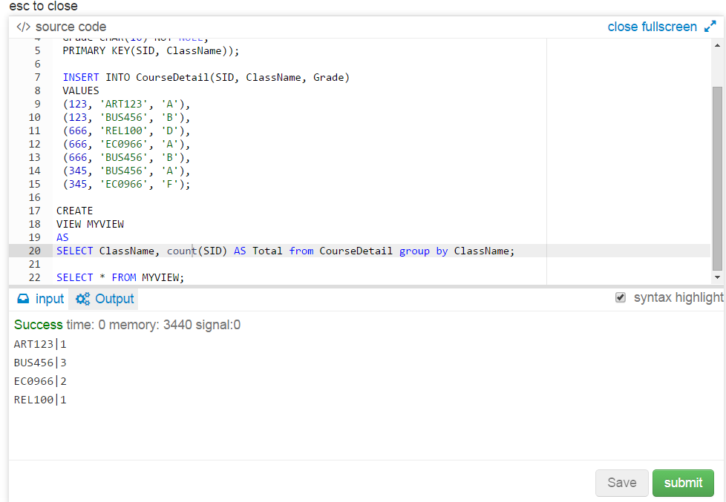

Q3

<https://ideone.com/eN1RaL>

CREATE TABLE Project

( ProjectID CHAR(20) NOT NULL,

Step INTEGER NOT NULL,

Status CHAR(2) NOT NULL,

PRIMARY KEY(ProjectID, Step));

INSERT INTO Project(ProjectID, Step, Status)

VALUES

('P100', 0, 'C'),

('P100', 1, 'W'),

('P100', 2, 'W'),

('P201', 0, 'C'),

('P201', 1, 'C'),

('P333', 0, 'W'),

('P333', 1, 'W'),

('P333', 2, 'W'),

('P333', 3, 'W');

SELECT ProjectID from Project

WHERE Status='C'

group by ProjectID

Having COUNT(ProjectID) = 1;

//screenshot

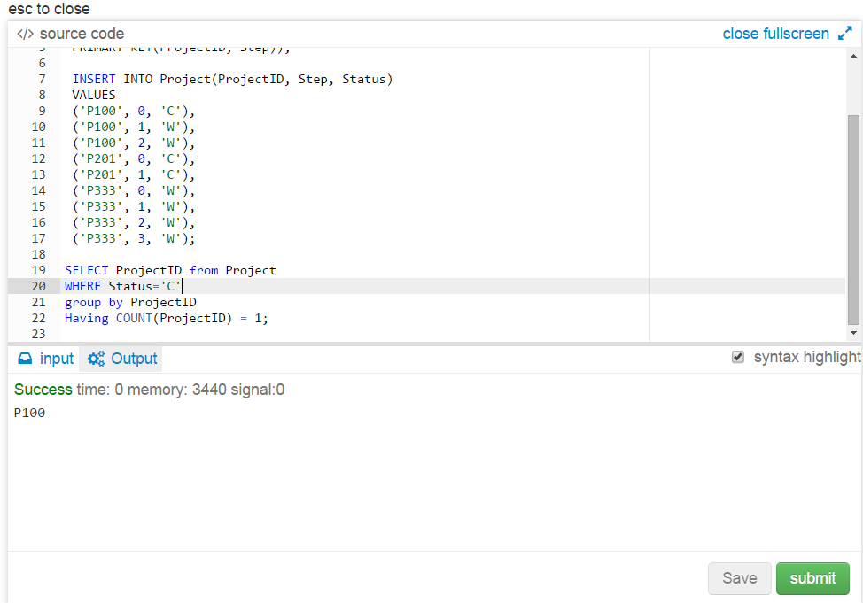

Q4

<https://ideone.com/YmEAeC>

CREATE TABLE Junkmail

( NAME CHAR(20) NOT NULL,

ADDRESS CHAR(2) NOT NULL,

ID INTEGER NOT NULL,

SameFam INTEGER,

PRIMARY KEY(NAME));

INSERT INTO Junkmail(NAME, ADDRESS, ID, SameFam)

VALUES

('Alice', 'A', 10, NULL),

('Bob', 'B', 15, NULL),

('Carmen', 'C', 22, NULL),

('Diego', 'A', 9, 10),

('Ella', 'B', 3, 15),

('Farkhad', 'D', 11, NULL);

**Query:**

DELETE FROM Junkmail

WHERE ID IN (

SELECT SameFam FROM Junkmail

where SameFam IS NOT NULL);

//Screenshot

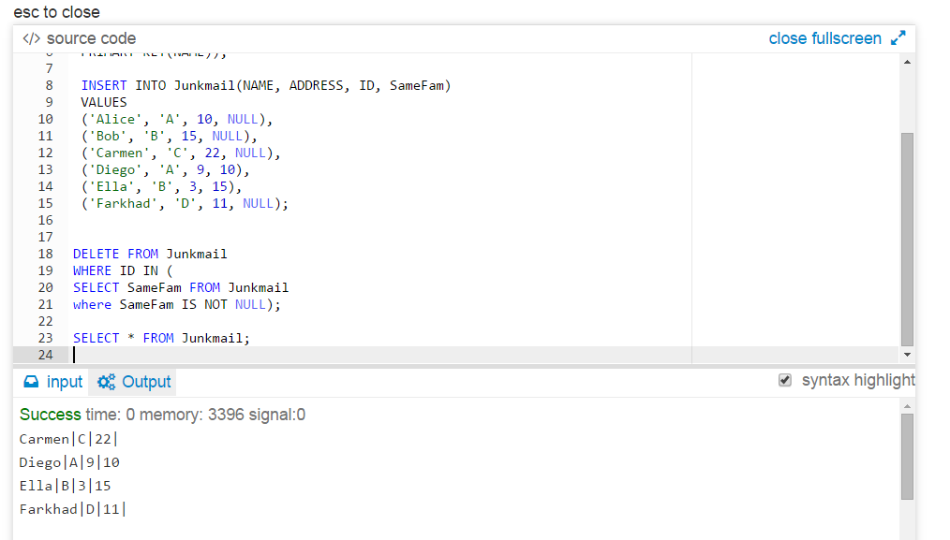

Q5

CREATE TABLE Chefs

( CHEF CHAR(4) NOT NULL,

DISH CHAR(100) NOT NULL,

PRIMARY KEY(CHEF, DISH));

INSERT INTO Chefs(CHEF, DISH)

VALUES

('A', 'Mint chocolate brownie'),

('B', 'Upside down pineapple cake'),

('B', 'Creme brulee'),

('B', 'Mint chocolate brownie'),

('C', 'Upside down pineapple cake'),

('C', 'Creme brulee'),

('D', 'Apple pie'),

('D', 'Upside down pineapple cake'),

('D', 'Creme brulee'),

('E', 'Apple pie'),

('E', 'Upside down pineapple cake'),

('E', 'Creme brulee'),

('E', 'Bananas Foster');

CREATE TABLE Dishs

( DISHNAME CHAR(100) NOT NULL,

PRIMARY KEY(DISHNAME));

INSERT INTO Dishs(DISHNAME)

VALUES

('Apple pie'),

('Upside down pineapple cake'),

('Creme brulee');

**//The first solution**

<https://ideone.com/wo12Fa>

SELECT CHEF

FROM Chefs, Dishs

WHERE Chefs.DISH = Dishs.DISHNAME

GROUP BY CHEF

HAVING COUNT(CHEF) = (SELECT COUNT(Dishs.DISHNAME) FROM Dishs);

// **the first solution screenshot**

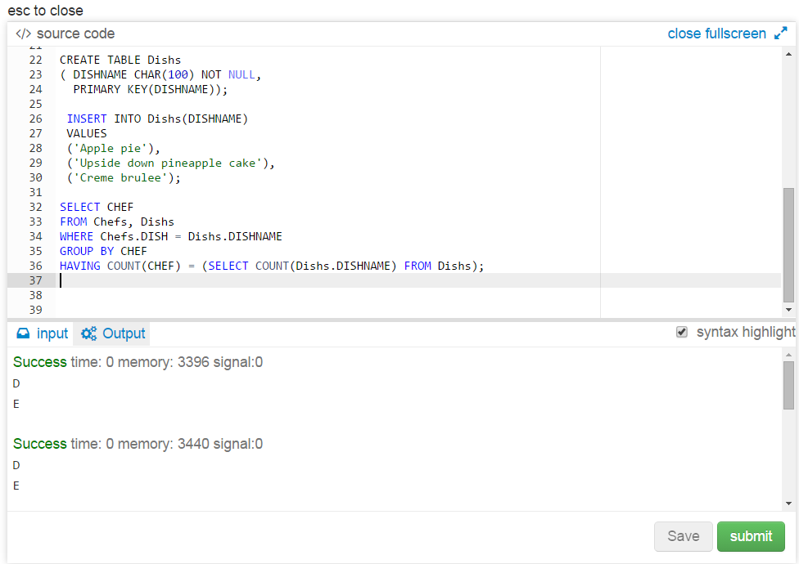

**//The second solution**

<https://ideone.com/GIgYCY>

SELECT CHEF FROM (

SELECT CHEF, COUNT(Chefs.CHEF) AS NUM

FROM Chefs

JOIN Dishs on Chefs.DISH = Dishs.DISHNAME

GROUP BY CHEF)

WHERE NUM IN (SELECT COUNT(DISHNAME) FROM Dishs);

// **the second solution screenshot**

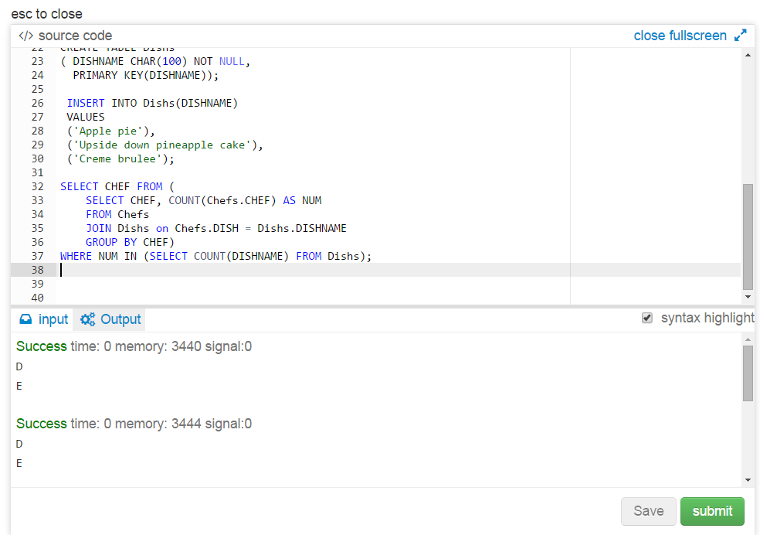

**//The third solution**

<https://ideone.com/H5FH4b>

SELECT CHEF FROM (

SELECT CHEF, COUNT(CHEF) AS NUM FROM (

SELECT CHEF

FROM Chefs

WHERE DISH IN (SELECT * FROM Dishs))

GROUP BY CHEF)

WHERE NUM IN (SELECT COUNT(DISHNAME) FROM Dishs);

**//the third solution screenshot**

